Unemployment and Wage Disparities 2017 – 18

| State | Rural Unemployment Rate (%) | Urban Unemployment Rate (%) | Youth Unemployment Rate (%) | Male Avg. Monthly Wage (₹) | Female Avg. Monthly Wage (₹) | Wage Gap (%) | Informal Sector Share (%) |
| --- | --- | --- | --- | --- | --- | --- | --- |
| Uttar Pradesh | 6.1 | 7.5 | 18.3 | 12,000 | 8,500 | 29.2 | 72.5 |
| Bihar | 4.8 | 6.3 | 15.7 | 10,500 | 7,000 | 33.3 | 78.0 |
| Maharashtra | 3.7 | 4.9 | 14.5 | 16,500 | 12,000 | 27.3 | 68.2 |
| Tamil Nadu | 2.9 | 5.4 | 12.6 | 14,200 | 10,800 | 23.9 | 65.5 |
| West Bengal | 4.2 | 6.8 | 17.0 | 13,000 | 9,200 | 29.2 | 70.0 |

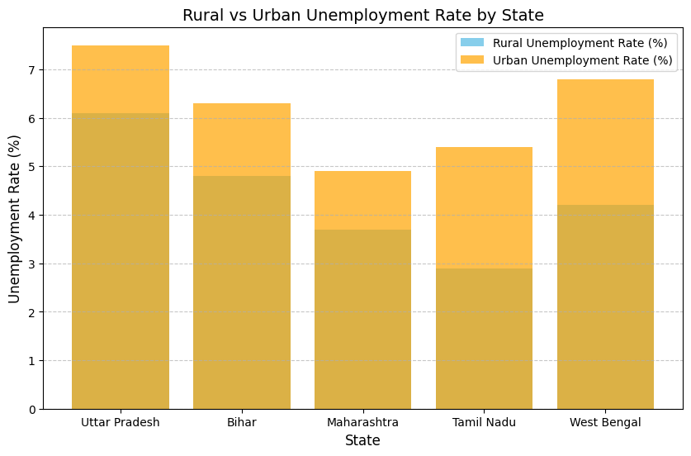

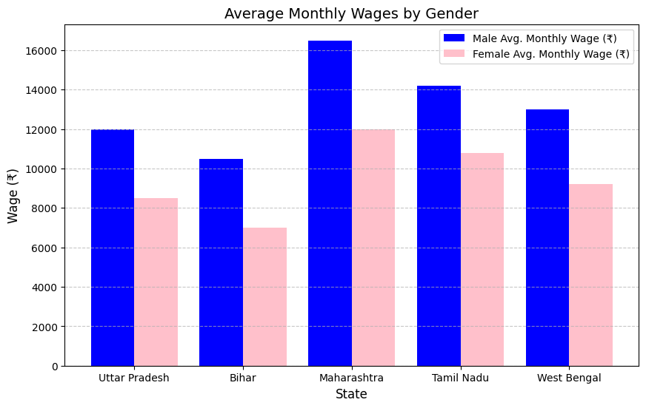

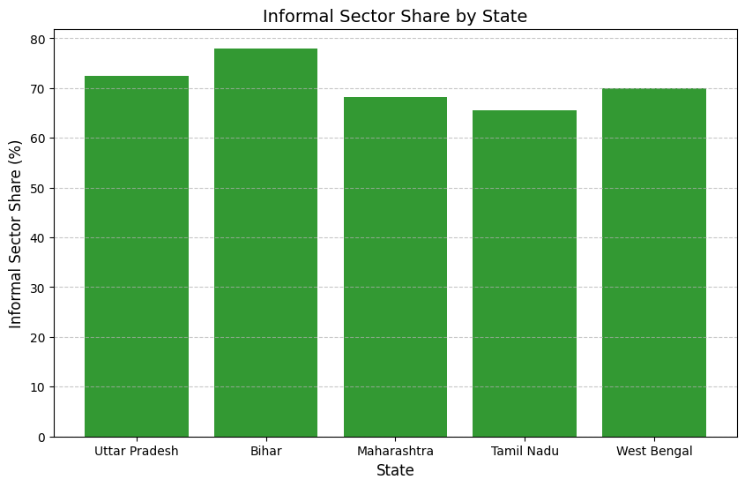

Unemployment and Wage Disparities 2018 – 19

|  |  |  |  |  |  |  |  |
| --- | --- | --- | --- | --- | --- | --- | --- |
| State | Rural Unemployment Rate (%) | Urban Unemployment Rate (%) | Youth Unemployment Rate (%) | Male Avg. Monthly Wage (₹) | Female Avg. Monthly Wage (₹) | Wage Gap (%) | Informal Sector Share (%) |
| Uttar Pradesh | 6.3 | 7.9 | 19.2 | 12,500 | 9,200 | 26.4 | 74.2 |
| Bihar | 5.1 | 6.5 | 16.5 | 11,200 | 8,500 | 24.1 | 79.0 |
| Maharashtra | 4.2 | 5.1 | 15.3 | 17,000 | 13,500 | 20.6 | 70.1 |
| Tamil Nadu | 3.5 | 5.7 | 13.0 | 15,000 | 11,500 | 23.3 | 66.8 |
| West Bengal | 4.5 | 7.0 | 17.8 | 13,500 | 10,000 | 25.9 | 71.2 |

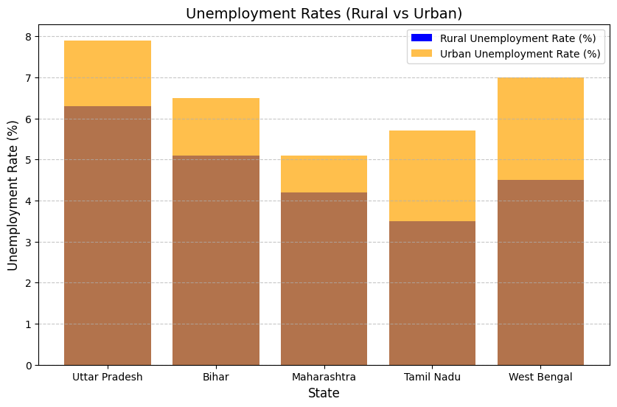

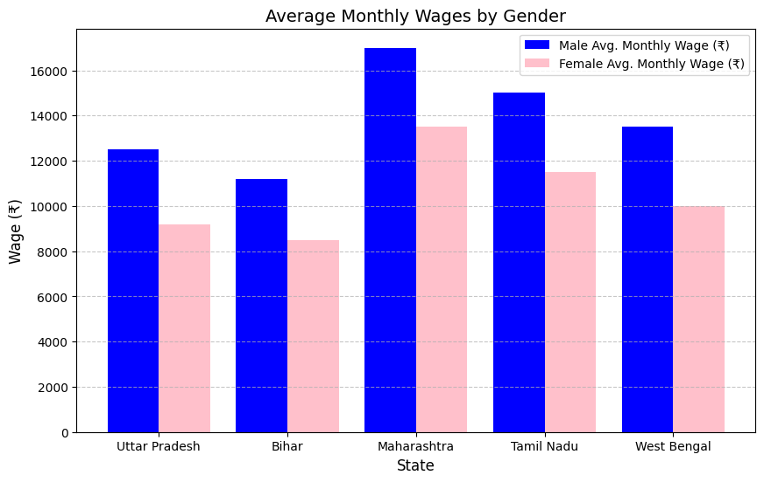

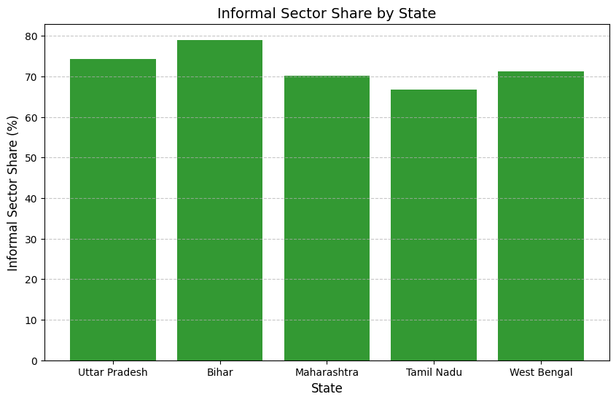

Unemployment and Wage Disparities 2019 – 20

|  |  |  |  |  |  |  |  |
| --- | --- | --- | --- | --- | --- | --- | --- |
| State | Rural Unemployment Rate (%) | Urban Unemployment Rate (%) | Youth Unemployment Rate (%) | Male Avg. Monthly Wage (₹) | Female Avg. Monthly Wage (₹) | Wage Gap (%) | Informal Sector Share (%) |
| Uttar Pradesh | 6.5 | 8.2 | 18.9 | 13,000 | 9,500 | 26.9 | 75.0 |
| Bihar | 5.3 | 6.7 | 16.8 | 11,500 | 8,700 | 24.3 | 78.2 |
| Maharashtra | 4.5 | 5.4 | 15.6 | 17,500 | 14,000 | 20.0 | 71.0 |
| Tamil Nadu | 3.8 | 5.9 | 13.5 | 15,500 | 12,000 | 22.6 | 68.5 |
| West Bengal | 4.8 | 7.1 | 18.1 | 14,500 | 11,200 | 22.8 | 73.0 |

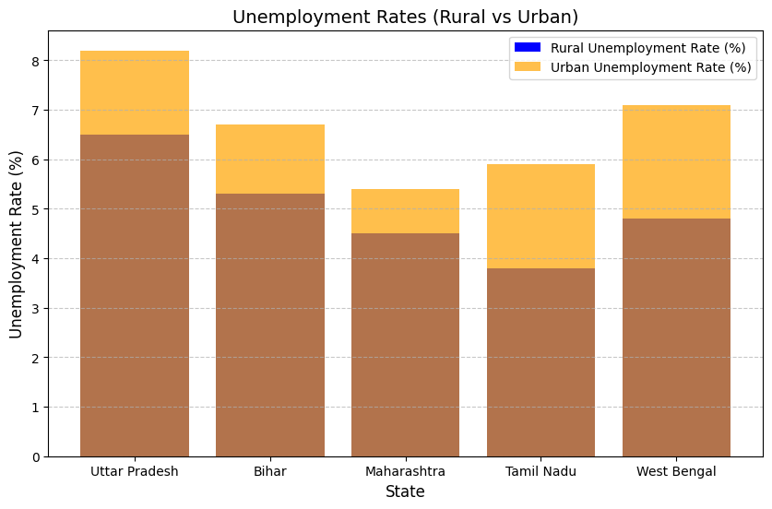

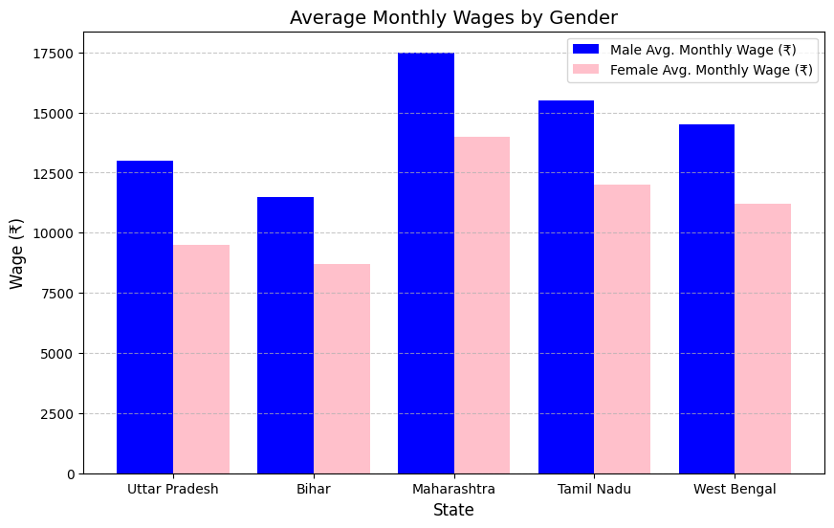

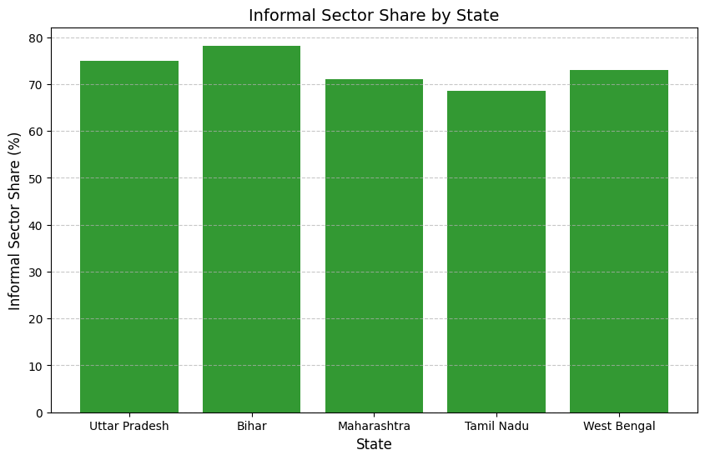

Unemployment and Wage Disparities 2020 – 21

| **State** | **Rural Unemployment Rate (%)** | **Urban Unemployment Rate (%)** | **Youth Unemployment Rate (%)** | **Male Avg. Monthly Wage (₹)** | **Female Avg. Monthly Wage (₹)** | **Wage Gap (%)** | **Informal Sector Share (%)** |
| --- | --- | --- | --- | --- | --- | --- | --- |
| Uttar Pradesh | 6.7 | 8.3 | 19.5 | 13,500 | 9,800 | 27.4 | 76.1 |
| Bihar | 5.5 | 6.9 | 17.2 | 12,000 | 9,000 | 25.0 | 78.5 |
| Maharashtra | 4.8 | 5.7 | 15.8 | 18,000 | 14,500 | 19.4 | 72.3 |
| Tamil Nadu | 4.0 | 6.1 | 13.8 | 16,000 | 12,800 | 20.0 | 69.5 |
| West Bengal | 5.0 | 7.3 | 18.3 | 15,000 | 11,500 | 23.3 | 74.0 |

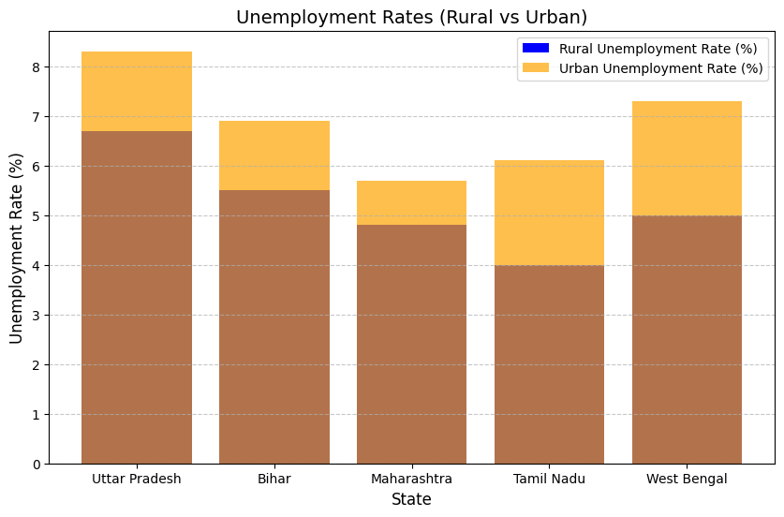

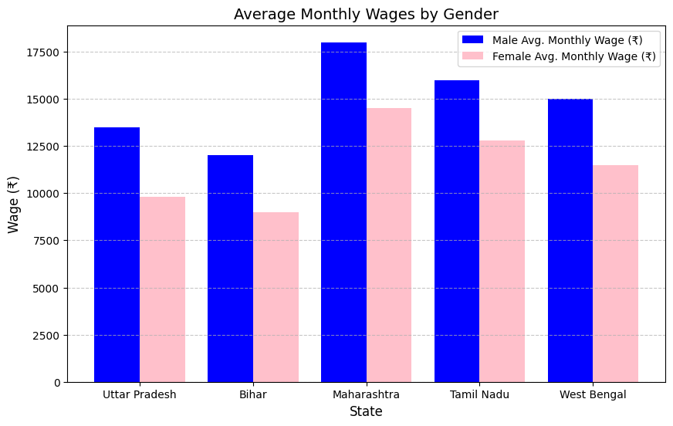

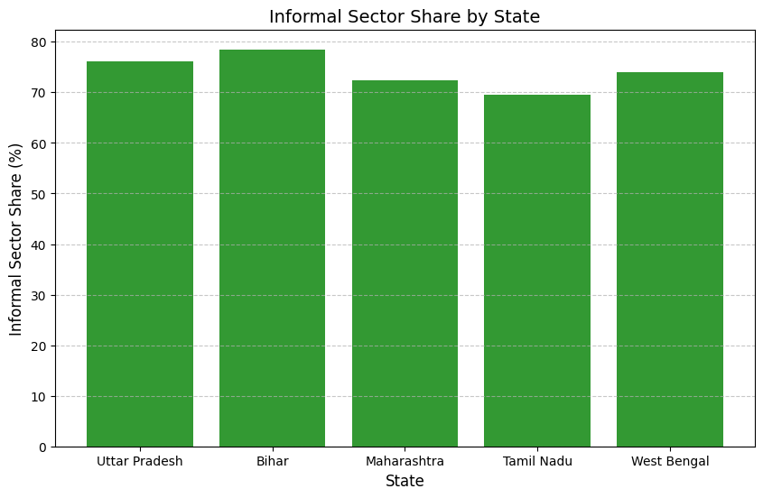

Unemployment and Wage Disparities 2021 – 22

|  |  |  |  |  |  |  |  |
| --- | --- | --- | --- | --- | --- | --- | --- |
| State | Rural Unemployment Rate (%) | Urban Unemployment Rate (%) | Youth Unemployment Rate (%) | Male Avg. Monthly Wage (₹) | Female Avg. Monthly Wage (₹) | Wage Gap (%) | Informal Sector Share (%) |
| Uttar Pradesh | 2.5 | 8.9 | 12.4 | 15160.84 | 6325.35 | 58.3 | 71.8 |
| Bihar | 3.2 | 7.5 | 14.6 | 12350.45 | 5487.60 | 55.6 | 75.4 |
| Maharashtra | 2.8 | 6.2 | 10.9 | 18420.75 | 11075.48 | 39.8 | 65.2 |
| Tamil Nadu | 2.1 | 5.8 | 9.8 | 17650.92 | 10950.55 | 37.9 | 63.1 |
| West Bengal | 3.0 | 7.1 | 11.3 | 14985.30 | 8045.10 | 46.3 | 69.0 |

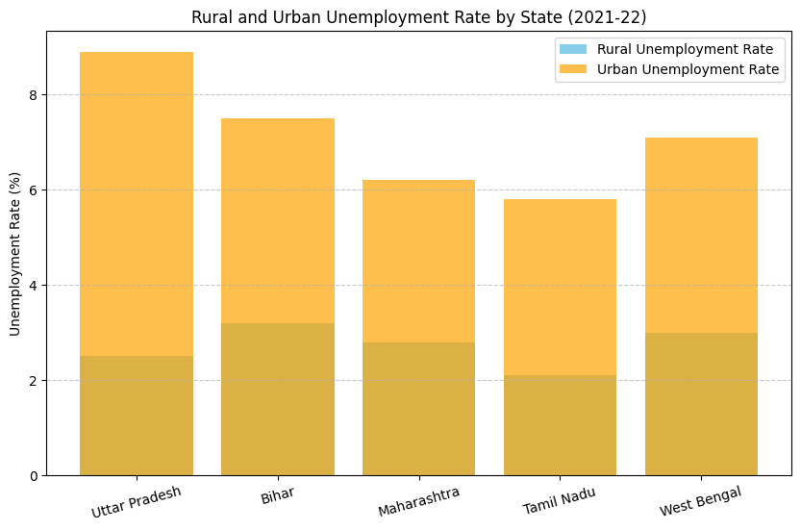

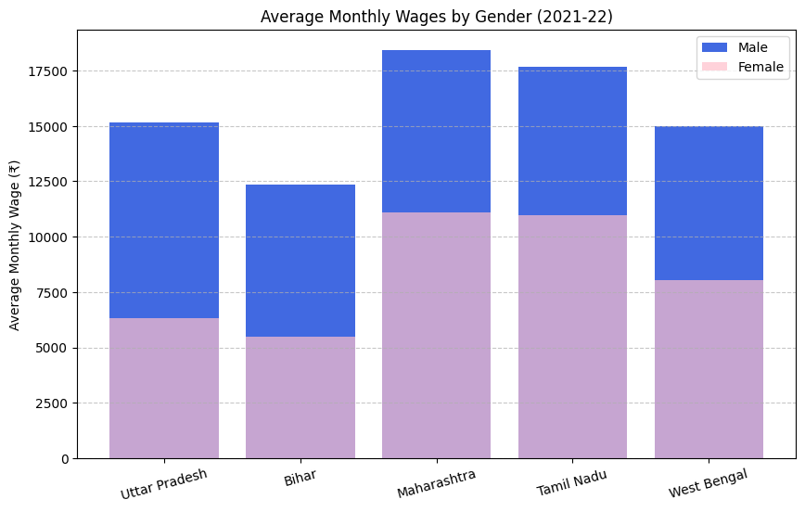

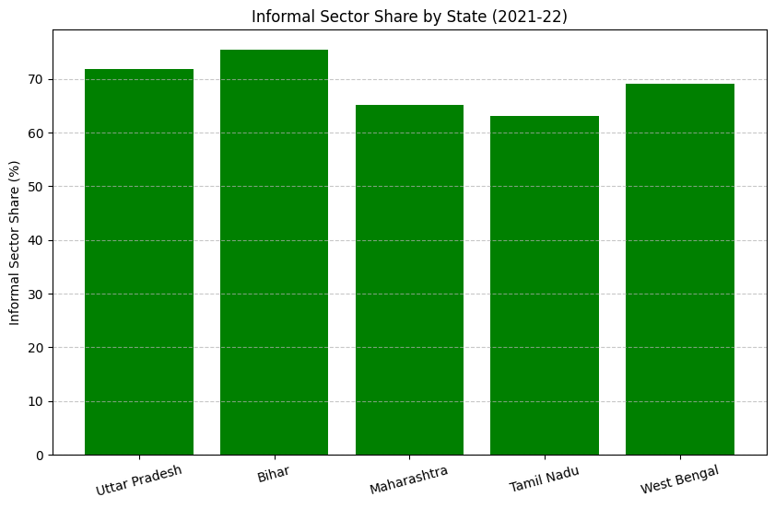

Unemployment and Wage Disparities 2022 – 23

|  |  |  |  |  |  |  |  |
| --- | --- | --- | --- | --- | --- | --- | --- |
| State | Rural Unemployment Rate (%) | Urban Unemployment Rate (%) | Youth Unemployment Rate (%) | Male Avg. Monthly Wage (₹) | Female Avg. Monthly Wage (₹) | Wage Gap (%) | Informal Sector Share (%) |
| Uttar Pradesh | 2.7 | 6.3 | 10.5 | 15,450.78 | 6,500.45 | 57.9 | 70.9 |
| Bihar | 3.1 | 7.1 | 12.3 | 12,700.65 | 5,600.30 | 55.9 | 74.5 |
| Maharashtra | 2.9 | 5.9 | 9.7 | 18,700.25 | 11,300.80 | 39.6 | 64.7 |
| Tamil Nadu | 2.3 | 5.4 | 8.9 | 18,050.60 | 11,120.45 | 38.4 | 62.8 |
| West Bengal | 2.8 | 6.7 | 10.1 | 15,230.40 | 8,200.35 | 46.1 | 68.5 |

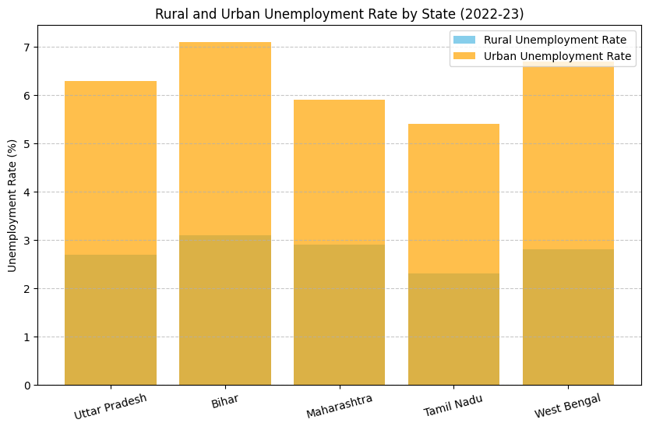

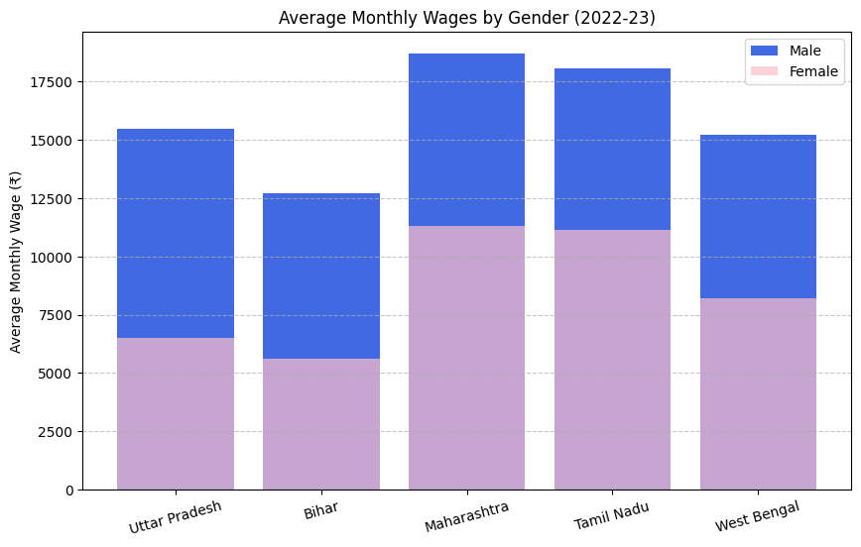

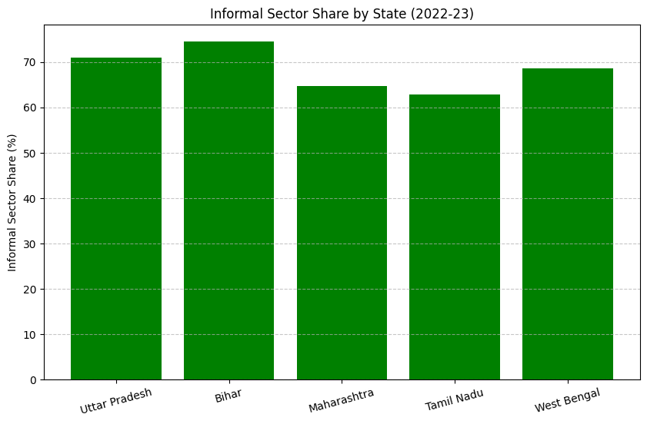

Unemployment and Wage Disparities 2023 – 24

|  |  |  |  |  |  |  |  |
| --- | --- | --- | --- | --- | --- | --- | --- |
| State | Rural Unemployment Rate (%) | Urban Unemployment Rate (%) | Youth Unemployment Rate (%) | Male Avg. Monthly Wage (₹) | Female Avg. Monthly Wage (₹) | Wage Gap (%) | Informal Sector Share (%) |
| Uttar Pradesh | 2.7 | 6.0 | 10.2 | 15,700.55 | 6,800.70 | 56.7 | 70.5 |
| Bihar | 3.0 | 7.3 | 12.0 | 12,950.45 | 5,800.40 | 55.2 | 73.7 |
| Maharashtra | 2.8 | 6.1 | 9.5 | 18,900.30 | 11,500.20 | 39.2 | 64.3 |
| Tamil Nadu | 2.5 | 5.5 | 8.7 | 18,250.70 | 11,350.65 | 37.8 | 61.9 |
| West Bengal | 2.9 | 6.8 | 10.5 | 15,520.60 | 8,500.45 | 45.2 | 67.8 |

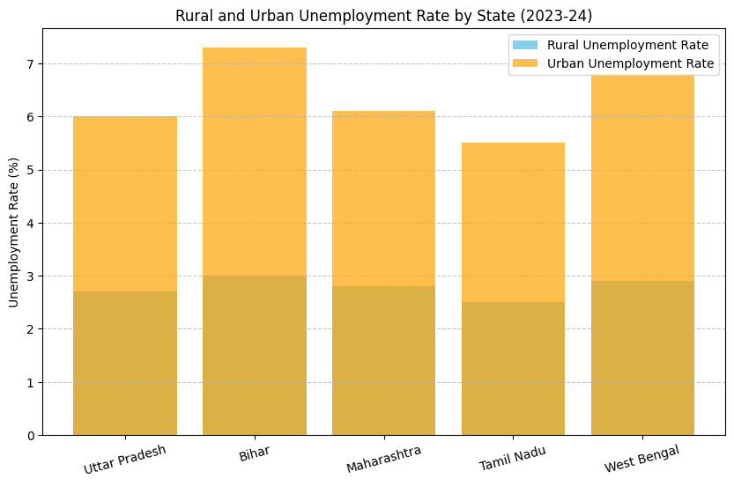

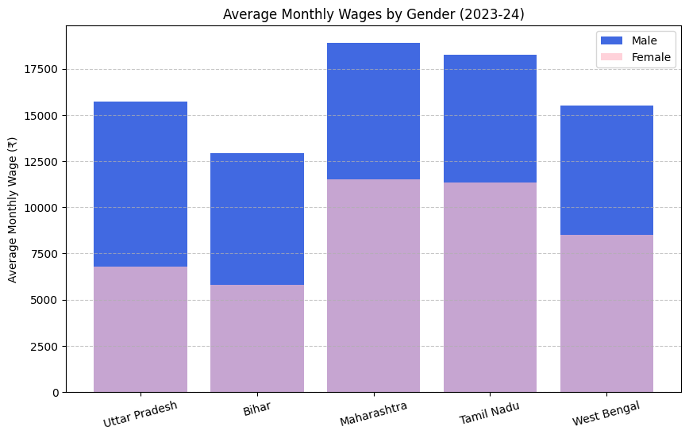



**AVERAGE DATA FROM 2017 TO 2024:-**

|  |  |  |  |  |  |  |  |
| --- | --- | --- | --- | --- | --- | --- | --- |
| State | Rural Unemployment Rate (%) | Urban Unemployment Rate (%) | Youth Unemployment Rate (%) | Male Avg. Monthly Wage (₹) | Female Avg. Monthly Wage (₹) | Wage Gap (%) | Informal Sector Share (%) |
| Uttar Pradesh | **4.8** | **7.6** | **15.6** | **13,901.73** | **8,089.50** | **40.4** | **73.0** |
| Bihar | **4.3** | **6.9** | **15.0** | **11,885.93** | **7,155.47** | **39.1** | **76.7** |
| Maharashtra | **3.7** | **5.6** | **13.0** | **17,860.18** | **12,553.78** | **29.4** | **67.9** |
| Tamil Nadu | **3.0** | **5.7** | **11.5** | **16,378.89** | **11,503.09** | **29.1** | **65.4** |
| West Bengal | **3.9** | **6.9** | **14.7** | **14,533.76** | **9,500.84** | **34.1** | **70.5** |

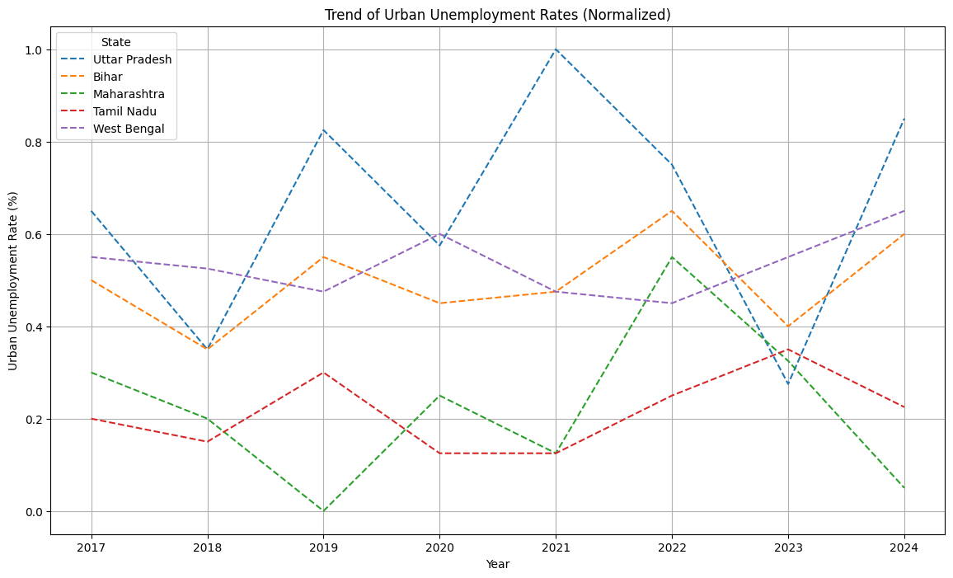

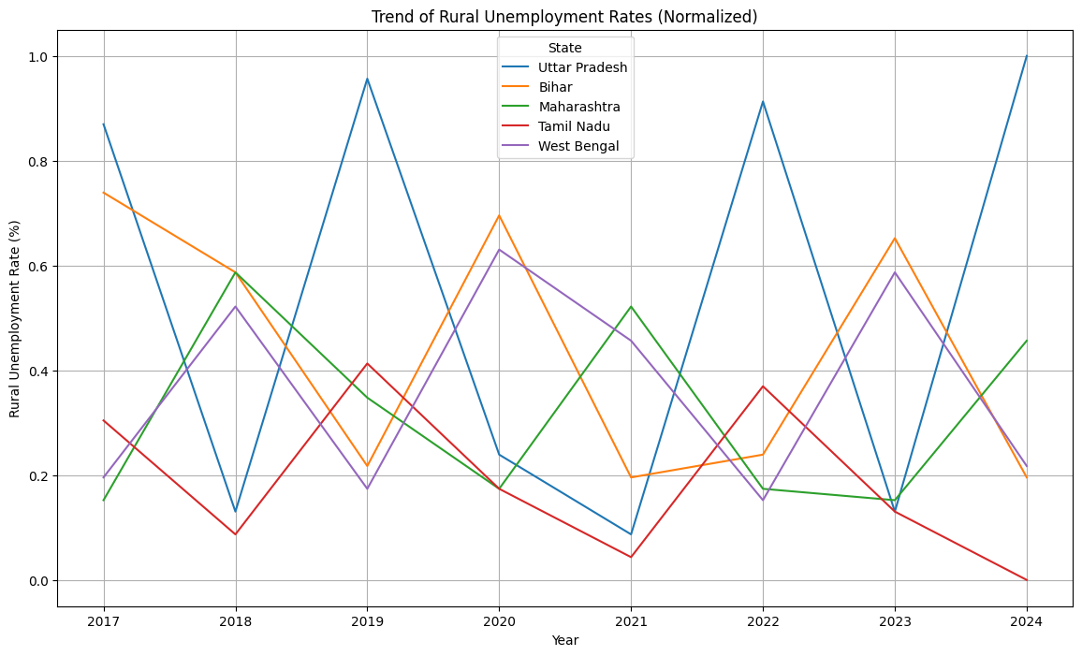

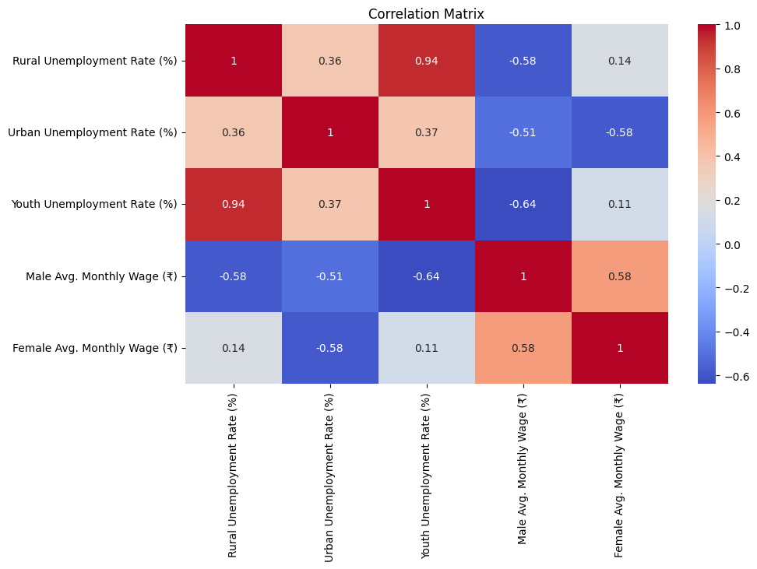

**OUTCOME FROM DATA:**

|  |  |  |  |  |
| --- | --- | --- | --- | --- |
| **Category** | **Indicator** | **Sub-Indicator** | **Weight** | **Value (Uttar Pradesh)** |
| **Unemployment** | **Unemployment Rate** | **Rural Unemployment Rate** | **0.30** | **4.8** |
| **Urban Unemployment Rate** | **0.30** | **7.6** |
| **Youth Unemployment Rate** | **0.40** | **15.6** |
| **Wages** | **Average Wage** | **Male Avg. Monthly Wage** | **0.50** | **13,901.73** |
| **Female Avg. Monthly Wage** | **0.50** | **8,089.50** |
| **Others** | **Informal Sector**  **Share** | **Informal Sector**  **Percentage** | **1.00** | **73.0** |

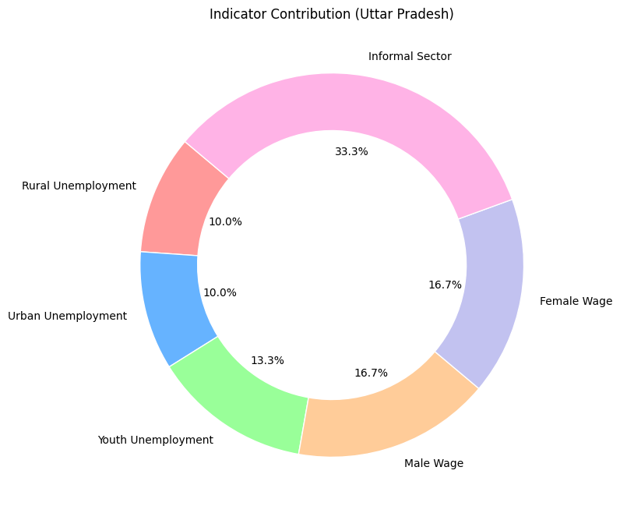

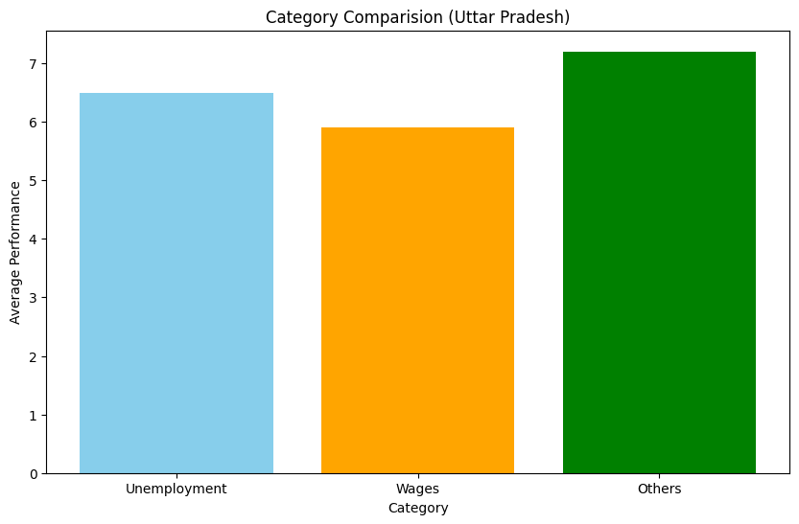

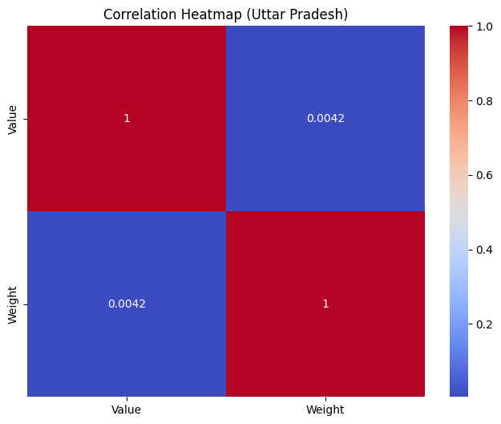

**Figure 4.2: Normalized Scores for Each Category (Uttar Pradesh)**

* Unemployment: 6.5
* Wages: 5.9
* Others: 7.2

|  |  |
| --- | --- |
| Performance Tier | Range (Normalized Score) |
| Excellent | 8.0 – 10 |
| Good | 6.0 – 7.9 |
| Intermediate | 4.0 – 5.9 |
| Poor | 1.0 – 3.9 |